Step-1 : create tables   
  
  
Table 1   
  
**- Customers table:**

- `customer_id` (Primary Key)

- `first_name'

- `last_name`

- `email`

USE `online retail store`;

CREATE TABLE Orders (

order_id INT PRIMARY KEY,

customer_id INT,

order_date DATE,

total_amount DECIMAL(10, 2),

FOREIGN KEY (customer_id) REFERENCES Customers(customer_id)

);

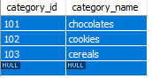

Table 2

**- Orders table:**

- `order_id` (Primary Key)

- `customer_id` (Foreign Key)

- `order_date`

- `total_amount`

CREATE TABLE Customers (

customer_id INT PRIMARY KEY,

first_name VARCHAR(50),

last_name VARCHAR(50),

email VARCHAR(100)

);

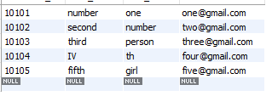

Table 3

**- Products table:**

- `product_id` (Primary Key)

- `product_name`

- `category_id` (Foreign Key)

- `price`

CREATE TABLE Products (

product_id INT PRIMARY KEY,

product_name VARCHAR(255),

category_id INT,

price DECIMAL(10, 2),

FOREIGN KEY (category_id) REFERENCES Categories(category_id)

);

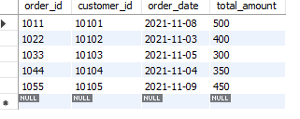

**- Categories table:**

- `category_id` (Primary Key)

- `category_name`

CREATE TABLE Categories (

category_id INT PRIMARY KEY,

category_name VARCHAR(100)

);

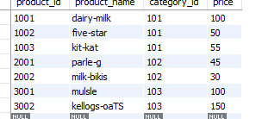

SECTION 1:

**Basic Queries:**

1. Retrieve a list of all customers along with their email addresses.

SELECT first_name, last_name, email FROM Customers;

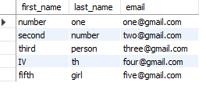

1. Find the total number of orders placed by each customer.

SELECT customer_id, COUNT(*) AS total_orders FROM Orders GROUP BY customer_id;

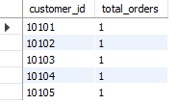

1. List all products along with their prices.

SELECT product_name, price FROM Products;

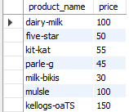

1. Retrieve the category with the highest number of products.

SELECT category_id, COUNT(*) AS product_count FROM Products GROUP BY category_id ORDER BY product_count DESC LIMIT 1;

